GoToWebinar Integration

#### What does this integration do?

Great question. This integration allows learners within your LMS to purchase* a product, and in doing so, be registered for a GoToWebinar (GTW) automatically. The integration will use the learner’s profile information as GTW registration information, so that the learner does not need to re-enter that information, or take another step for registration.

Additionally, when the learner launches the product in the LMS, it will open a new window, and automatically open the GTW they’ve registered for.

The webinar itself is still taking place through GTW, and attendee registrations are also taking place through the GTW portal. This integration simply takes the work of registering for the webinar, away from the learner.

So to sum it up:

* As an admin you’ll still set up your webinars through GTW
* You’ll then create a corresponding course item in the LMS
* Attendees will purchase this course item through LMS
* Attendees will be automatically registered for webinar
* Attendees will still receive confirmation/reminder emails through GTW as usual
* Attendees can launch their LMS product to join the webinar easily
* Webinar metrics within the GTW system will still work as normal

*\* Keep in mind that you can set the cost, or enable the product as Free if you wish*

Next, we’ll have a look at Preparing your GoToWebinar, and then, Creating the Linked Product in LMS

## Preparing your GoToWebinar

First, you’ll need to create a webinar within GoToWebinar. Next, you’ll want to obtain the “Webinar ID” from the webinar you’d like to link up.

From the “GoToWebinar” man menu on the left, select “My Webinars”:

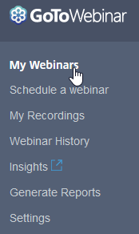

Next, select the “Edit” link for the specific webinar you’d like to link up:

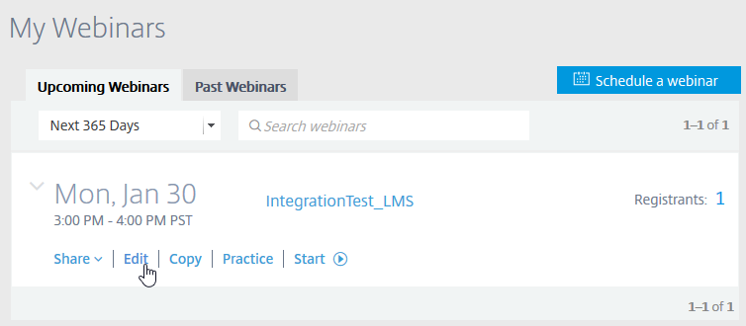

You should now be looking at the “Manage Webinar” page for your selected webinar.

Within the “Share Your Webinar” section, copy the “Webinar ID”:

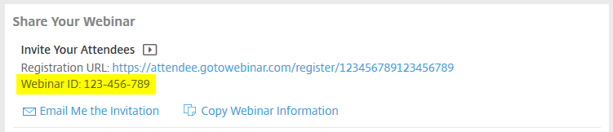

## Creating the linked LMS Product

Now it’s time to create the Webinar product in the LMS. Begin as you would normally when creating a product in the LMS:

While logged in as an admin to the LMS, select the “Admin” tab

From the left-panel, select “Products”, then “Create”

Select the “Webinar” product type, and then select “Go”:



Enter the webinar information as you would normally, taking particular note of the “Provider” and “Webinar ID” fields. These are how you’ll link your product up to the actual GoToWebinar.

Select “Goto Webinar” as Provider, and enter the “Webinar ID” you copied, without the hashes:

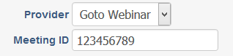

Save your product, and be sure to create a corresponding Catalog Item as you would normally, to enable the product for purchase by learners.

## User Perspective

When the learner purchases and launches the product, the integration will use their profile information to register them for the webinar.

When the learner launches the product, f the webinar is active, they will join the webinar. Otherwise, if the webinar is not currently active, they’ll simply see this message from GoToWebinar:

